PowerSchool Students in a Course - DDE
Finding students who are in a math class in semester 2 – Use the following instructions to pull information from PowerSchool using DDE.

Instructions:
- On the PowerSchool start page, choose System from the main menu.
- Then choose Direct Database Export (DDE) from the list.
- For Current Table: choose CC(4)
- Under Search Sections filter the term ID = Internal TermID
TermID = 2302(S2)

- Also under Search Sections filter the Course_Number contains MAT

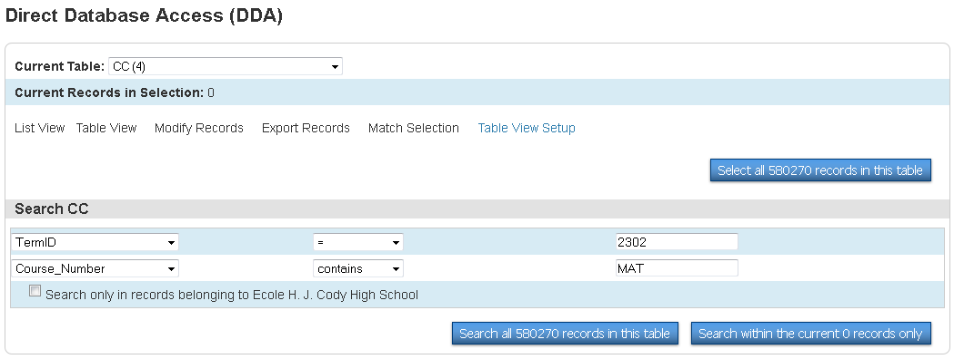

- Once you have all the above information in the screen then Search all #### records in this table

- If your search is successful, then you will notice the “0” in the Current Records in Selection change to the number of records you pulled in your search. Example below changed to 347 records found.

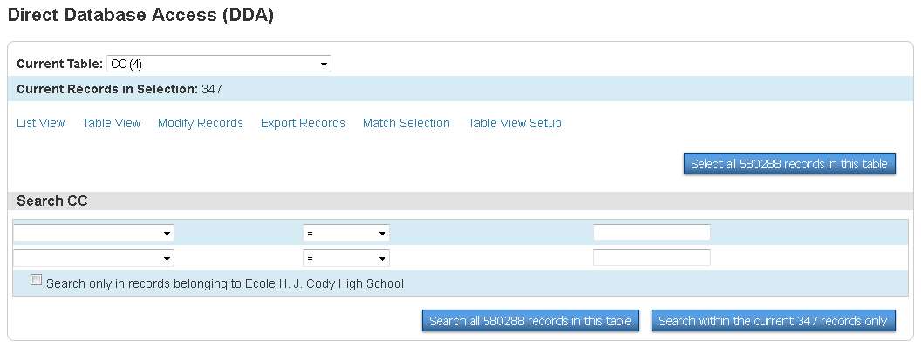

- Click - Export Records.

- On the next screen input the following information into the Field Delimiter area.
NOTE: instead of the table number you could use the table name if you would rather (must be EXACT name of the table).
Ex: instead of [5] you could use [Teachers] or instead of [2] you could use [Courses]
Just remember that regardless of your preference above,+ you must use the [ ] for either option.
[1]lastfirst
[2]course_name
[5]lastfirst
Expression
DateLeft
TermID

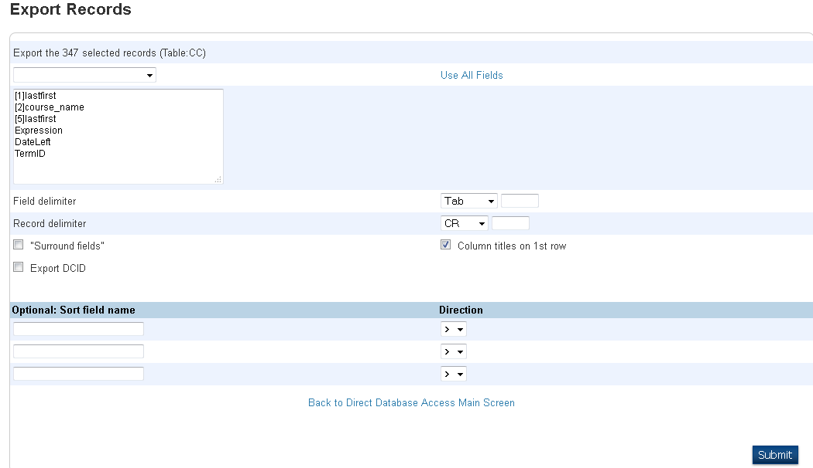

All of these fields can be found in this drop down menu, except for the ones pulling from other tables [ ] , which will have to be typed in.

- Remember to click on SUBMIT

- This information will now be pulled into EXCEL where you can quickly see all the students taking Math in your school.

