PowerSchool Attendance - DDE
Attendance Information – Use the following instructions to pull information regarding attendance (date range) from PowerSchool using DDE.

Instructions:
- On the PowerSchool start page, choose System from the main menu.
- Then choose Direct Database Export (DDE) from the list.
- For Current Table: choose Attendance(157).
- Under Search Attendance, filter for the date range needed to pull attendance data.
The example below is from September 3, 2013 – March 31, 2014.
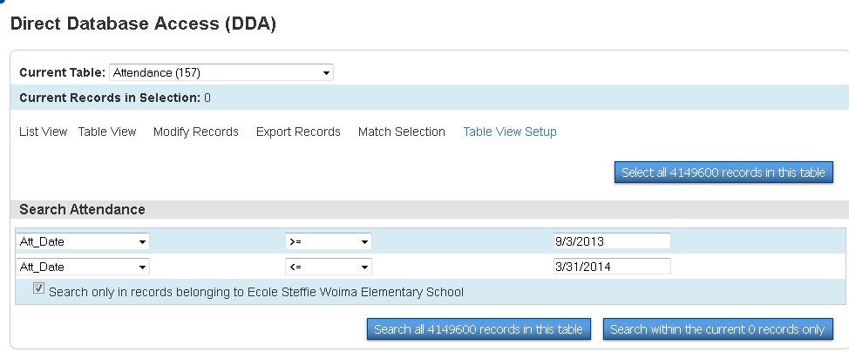

- Once the search criteria is set click on Search all #### records in this table.

- If the search is successful, the “0” in the Current Records in Selection change to the number of attendance records found to pull from the search. Example below changed to 13015 records found.
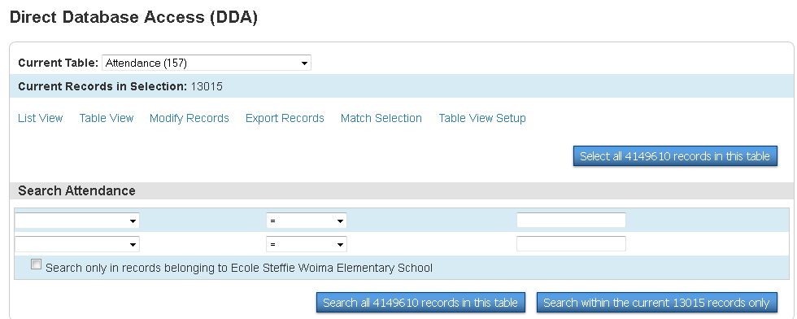

- Now Export Records.

- On the next screen put the field and table information into the Field Delimiter area needed to analyze the attendance data. Below are some examples of fields to include, but this is only a suggestion and can be adjusted to meet individual needs.
[01]lastfirst
[01]grade_level
Att_Date
[156]Att_Code
[156] description
Att_Comment
[138]Name
[4]Course_Number
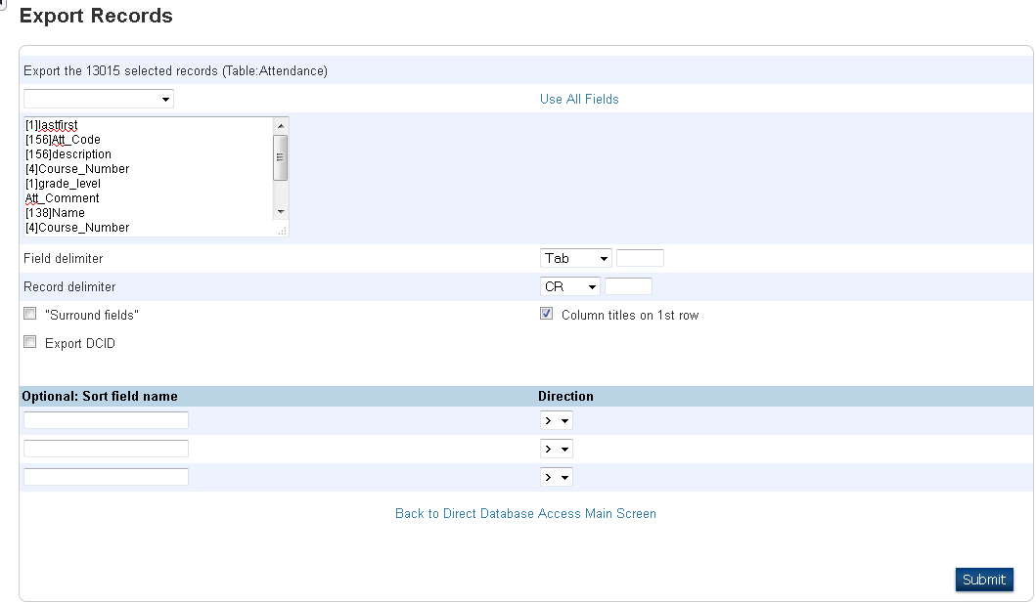

All of these fields can be found in this drop down menu, except for the ones pulling from other tables [ ], which will have to be typed in.

- Remember to click on SUBMIT.

- This information will now be pulled into EXCEL where it can be sorted as needed.

